WebPivotTable Tutorial

Learning Objectives
The tutorial covers concepts and practice with WebPivotTable. At the completion of this tutorial, you should have acquired the knowledge and skills to:
- Understand the relationship between pivot tables and data cubes
- Understand the process to design a pivot table and pivot chart
- Using WebPivotTable, create a basic pivot table and revise it with additional features

Pivot Tables
Data warehouse processing requires a multidimensional data representation that is convenient for business analysts. Data cubes, a widely accepted representation of multi-dimensional data, support operations for decision support processing by business analysts. In a data cube, cells contain numeric data called measures while rows and columns contain dimensions to organize the cells. In the Data Warehouse Essentials textbook, sections 2.1 in Chapter 2 and 4.1 in Chapter 4 provide conceptual background about data cubes and details about online analytic processing including WebPivotTable, Pivot4J, and Microsoft MDX. This tutorial supplements textbook material with guided practice about WebPivotTable.
Pivot tables and pivot charts provide a convenient and flexible interface for manipulating data cubes. Pivot tables display data in rows and columns and allow convenient rearrangement of the row and column headings. Pivot charts display numerical data graphically to provide insights to business analysts. Pivot tables support dynamic manipulation of the row and column headings.
This section provides practice with pivot tables and pivot charts. This tutorial will use a free web tool (WebPivotTable) to build the pivot table and chart. The website tool provides similar functionality and interface as pivot tables in Microsoft Excel.

Adventure Works Cube
WebPivotTable uses the Microsoft Adventure Works cube as a demonstration. The Adventure Works cube contains 16 dimensions with 47 measures. To use the cube, you should go to http://webpivottable.com and click on Open in New Window in the middle of the page (Figure 1). In the Demo page (https://webpivottable.com/releases/latest/demo.html), click on the Open Dialog button in the top of the page. In the Connect data source window (Figure 2), select OLAP Mode and then select Sample Microsoft Analysis Service (Figure 3). In the Connect data source window, select “WIN-IA9HPDV1RU5” for the DataSource, then “Adventure Works DW Standard Edition” for the Catalog, and finally “Adventure Works” for the Cube Name as shown in Figure 4. After selecting the Cube Name, the cube opens with panes on the right (Figure 5).
You are now ready to start. When using a cube, WebPivotTable acts as a client connected to an OLAP server. Since an external OLAP server performs calculations, you may encounter slow performance or a server error as the pivot table refreshes for operations performed on the OLAP server.
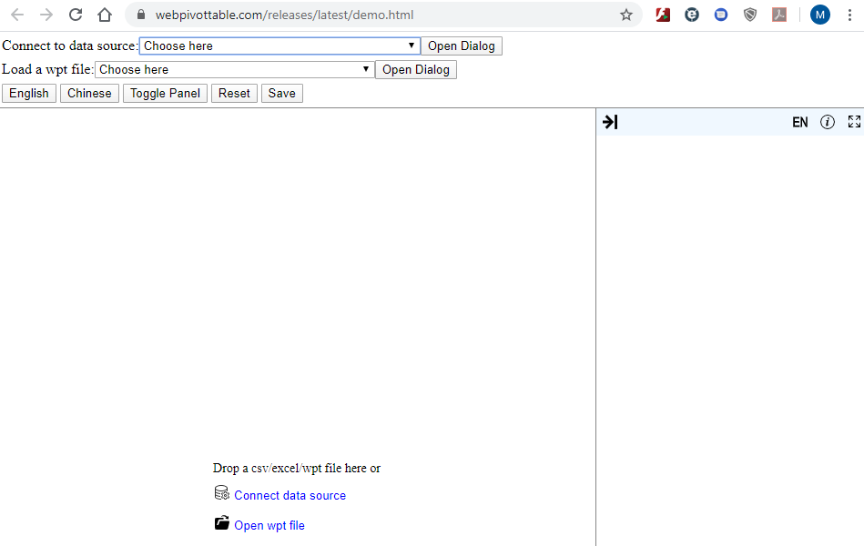
Figure 1: WebPivotTable in an Open Window
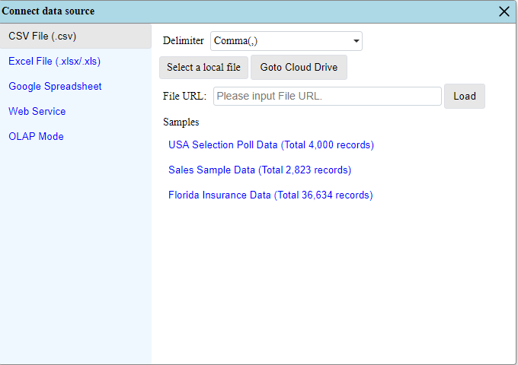
Figure 2: Connect Data Source Window with Options for Data Sources
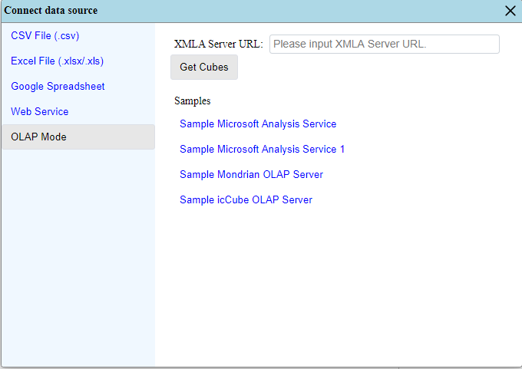
Figure 3: Connect Data Sources Window with OLAP Mode Selected
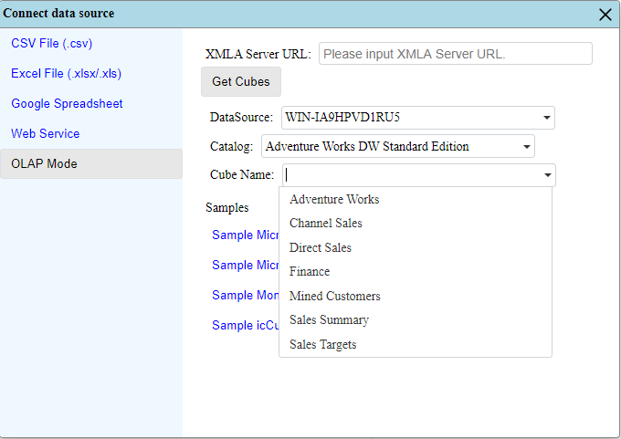
Figure 4: Connect Data Sources Window with OLAP Mode Options
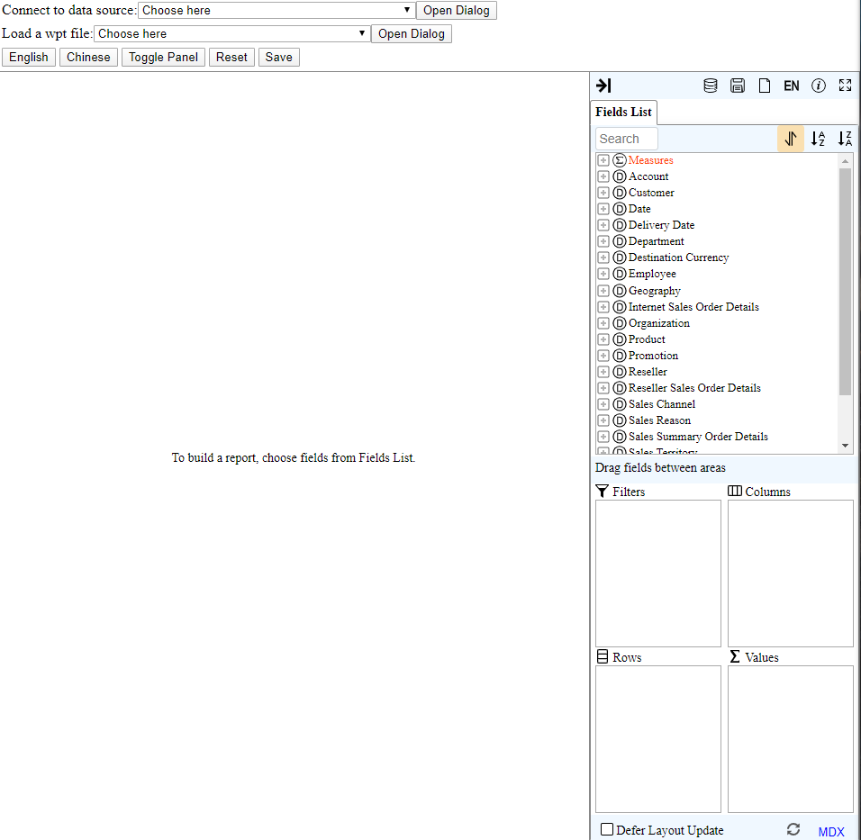
Figure 5: Demo Window after Adding Adventure Works Cube

Pivot Table Terminology
Figures 6 and 7 present a pivot table and pivot chart for the Adventure Works cube. Table 1 provides explanations for the selected parts of Figure 6 along with some additional terms.
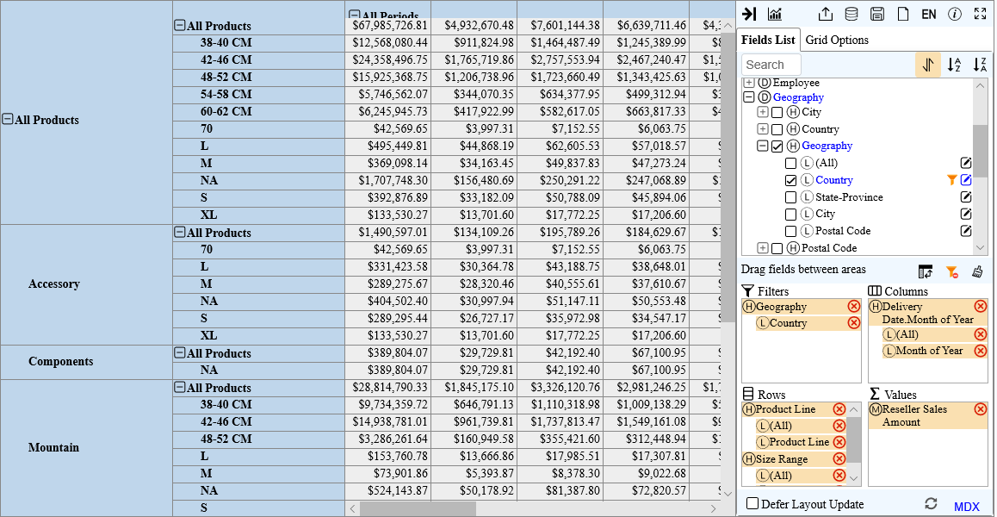
Figure 6: Sample Pivot Table
Table 1: Terminology for Pivot Tables
Term | Meaning
Filters | Restricts data that appears in the pivot table. Country is a filter field. The user can choose to display pivot table data for selected sizes by choosing a value for the filter field.
Rows | A dimension appearing in the row area of a pivot table. Product Line and Size Range are row fields.
Columns | A dimension appearing in the column area of a pivot table. Delivery Date.Month is a column field.
Values | A measure appearing in the cell area of a pivot table. The numeric values in the cells are the measure values for the combination of the row and the column values. For example, $12,568,080.44 is the reseller sales amount for 38-40 CM size range of All Products in All Periods.
Chart | A chart appears when the chart button () is selected. The chart represents the values from the pivot table. See Figure 7.
Fields List | Specifies the details of the data cube. Numeric values are under the Measures. Fields following measures are dimensions.
Areas | The Areas pane below the Fields List specifies the pivot table with filters, columns, rows, and values.
Field expand/collapse symbol | The sign at the left side of each field. The user can select values to display or hide by clicking the +/- symbol.
Item | A data value within a field. Expanding a field displays its items, while collapsing a field hides its items.

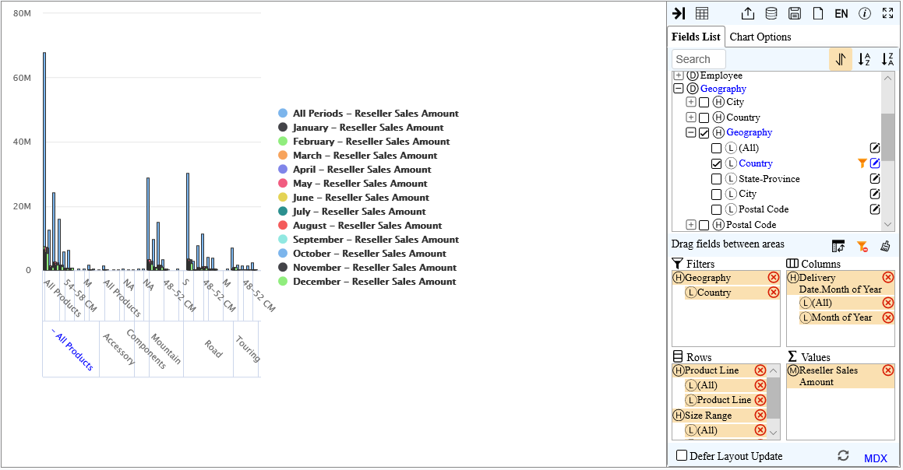
Figure 7: Sample Pivot Chart

Creating Pivot Tables
The following steps demonstrate creation of a pivot table in WebPivotTable. After creating the pivot table, you will modify it and manipulate its data.
- Understand Field Placement: To place a field in an area of a pivot table, select it in the fields list such as the Product Categories field () in the Product dimension. You will see a dropdown menu (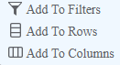) allowing you to select the area of the pivot table. Alternatively, you can select the checkbox () by a field (instead of using the dropdown menu) to place the field in the rows area. After using the dropdown menu, a check appears on the checkbox by the field.
- Place Fields on the Diagram: Using the method in (1) with the drop down menu, place the Product Categories field (from the Product dimension) in the Rows area, the Date.Month of Year field (from the Date dimension) in the Columns area, and the Reseller Sales Amount field (from the Measures) in the Values area. If you select the check box directly instead of the drop down menu, you can drag the field from the Rows area to the Columns area. I dragged it into the Columns area. The worksheet should look like Figure 8.
- View the Pivot Table as a Pivot Chart: The chart is not shown by default on the page. To view the pivot chart, select the Switch to Pivot Chart button (). Figure 9 shows the pivot chart. To switch back to the pivot table, select the Switch to Pivot Table button ().
- Configure Pivot Table: Using the current pivot table view, use the collapse symbol so that only the four (top level) categories are shown in the rows of the pivot table (Figure 10). If you move the horizontal slider, the row categories are not fixed so that the row labels disappear.
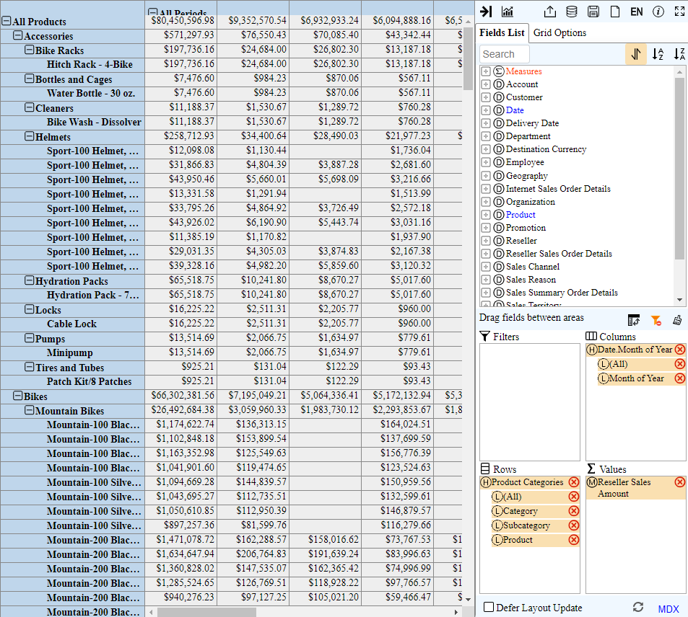
Figure 8: Pivot Table with Fields in Areas
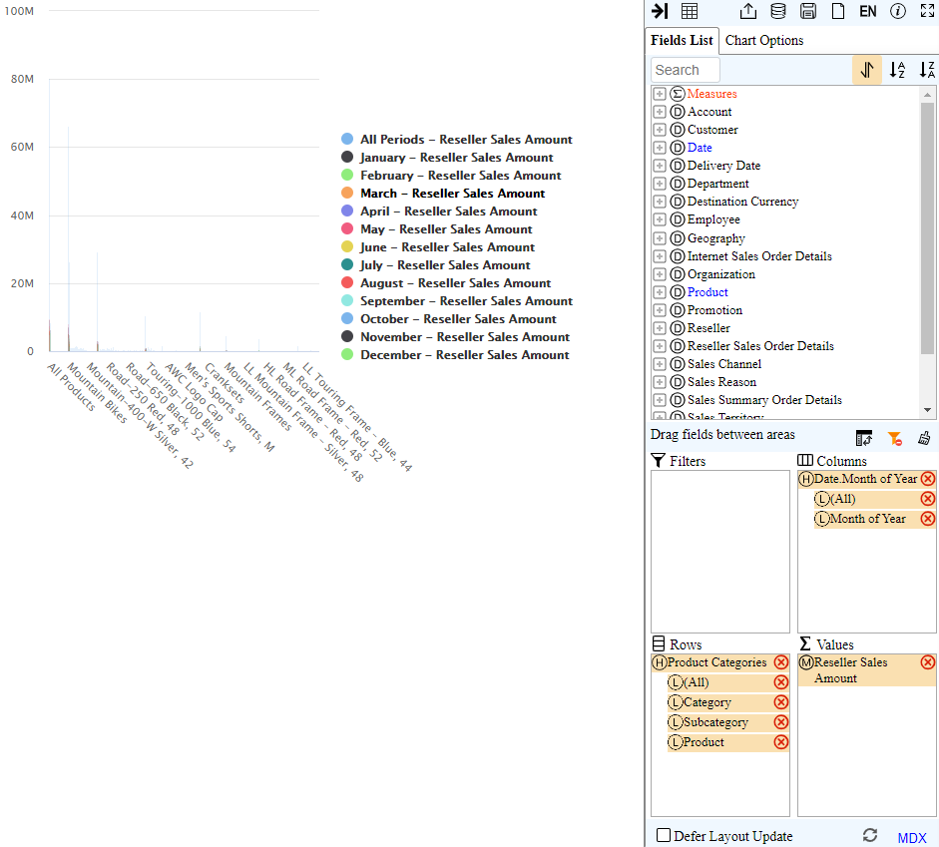
Figure 9: Pivot Chart after Selecting Switch to Pivot Chart Button
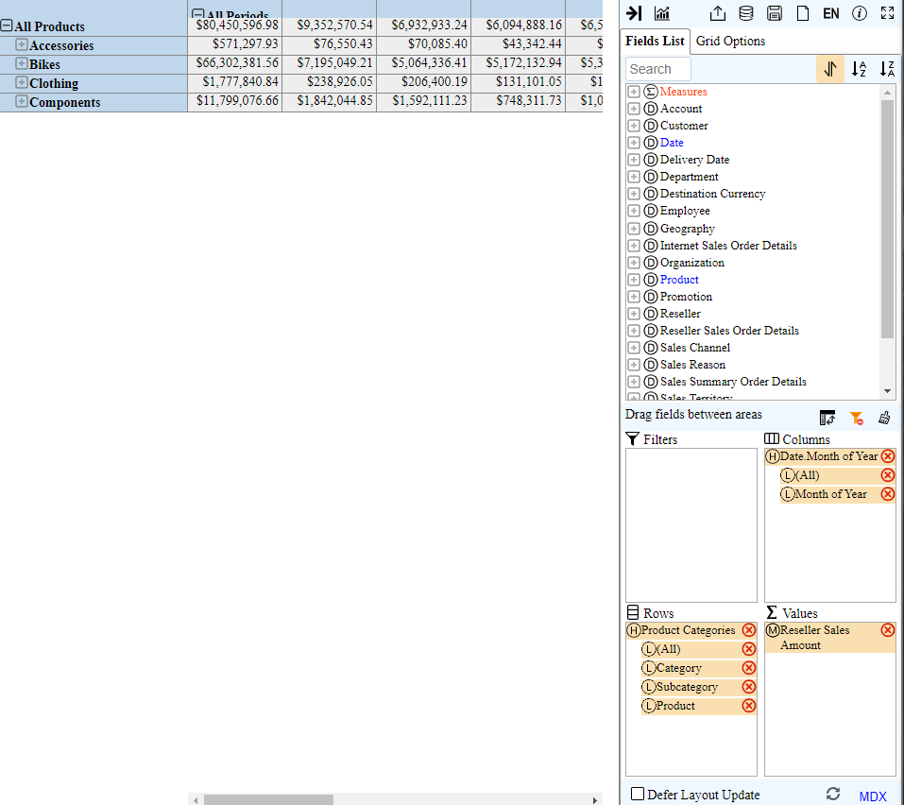
Figure 10: Pivot Table with Row Labels Collapsed

Extending the Pivot Table
The pivot table in the previous section is somewhat limited because it has only one dimension in the rows/columns field. In addition, the pivot table lacks a filter field to restrict the data displayed. In this section, we add these elements to the previous pivot table and then demonstrate some additional features of pivot tables. To extend the pivot table of the previous section, you should follow these steps.
- Modify Pivot Table Fields: In the Fields List, place the Geography→Country→Country field in the Geography dimension in the Rows area. Make sure that the Country is below Product Categories. Figure 11 shows the revised pivot table.
- Rollup the Pivot Table: You can drill down or rollup in the rows and columns fields using the expand button () or collapse () button. Alternatively, you may drill down/rollup single items by clicking on the sign next to the item’s name. Configure the pivot table to collapse product categories using the – button as shown in Figure 12. Note that the + symbol displays after rolling up product categories. Note that the page may be slow or timeout due to server overhead for computations on the pivot table.
- Filter the Pivot Table: Drag the Country field from the Rows area to the Filters area. To set the filter, select the Country item (). In the Field List window, select Label if required. Uncheck all boxes except “Canada” and “United States” (Figure 13). Figure 14 shows the pivot table after filtering. Note reduction in reseller sales amounts after applying the filter. For example, reseller sales amount for all products in all periods has been reduced to $67,985,726.81 from $80,450,596.98.
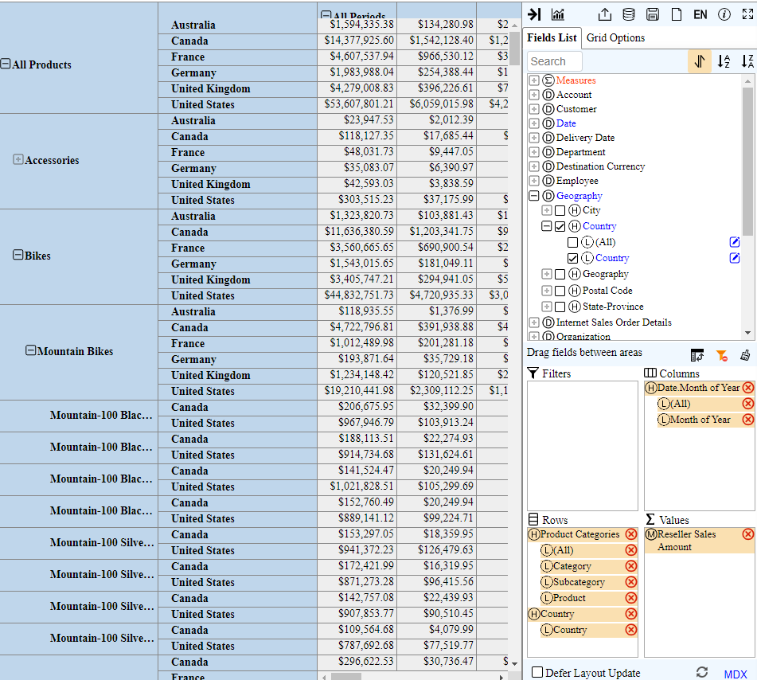
Figure 11: Pivot Table after Adding Size Range and Country
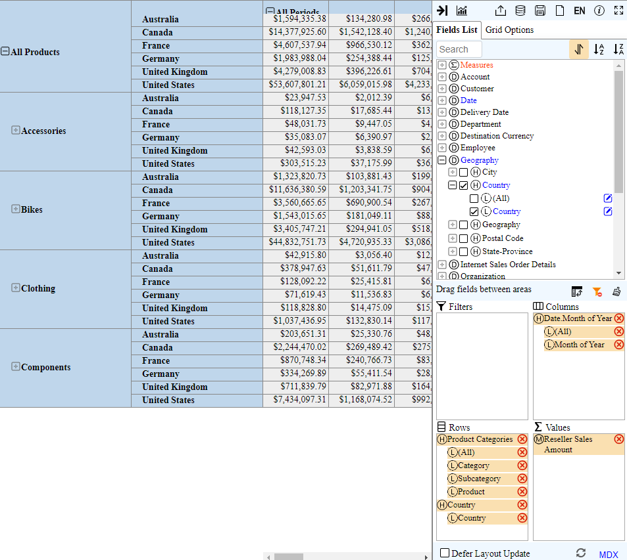
Figure 12: Pivot Table after Rollup of Product Categories
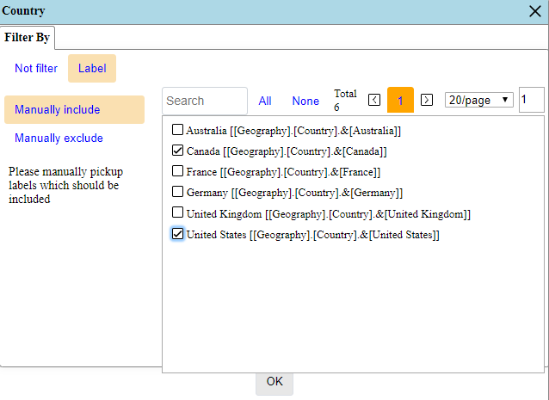
Figure 13: Filter By Window with Countries Selected
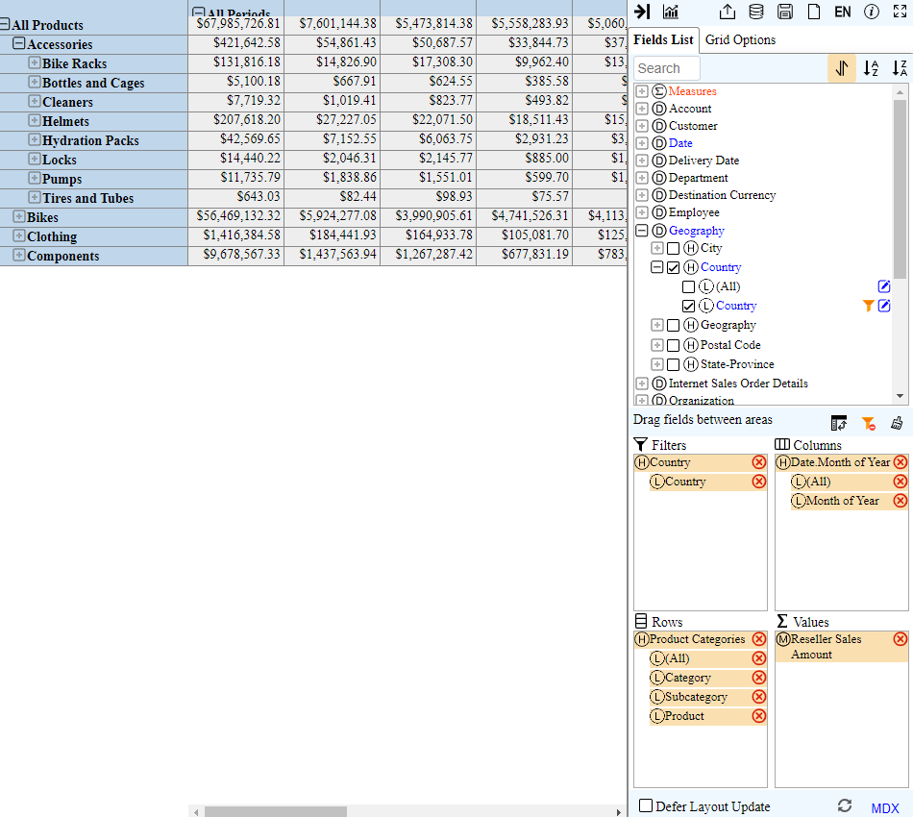Figure 14: Pivot Table after Filtering on Canada and United States

MDX
WebPivotTable supports Microsoft Multidimensional Expressions (MDX) with the ability to display and execute MDX SELECT statements. You can display the MDX statement for a pivot table using the MDX button. Figure 15 shows the MDX SELECT statement for the last pivot table (Figure 14). Because the window is not resizable, the complete code does not appear. The scroll bar can be used to see the missing part of the code. The missing parts are SET statements. Figure 15 shows the complete MDX SELECT statement.
You can modify an MDX statement to change the pivot table. Figure 16 shows a modification of the WHERE clause to replace United States and Canada with France and Germany as filters. After you modify the WHERE clause, you can use the Run button to modify the pivot table. Figure 17 shows the pivot table with the MDX statement after executing the MDX statement with the Run button.
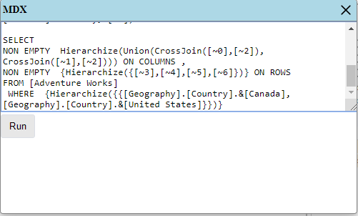
Figure 15: Partial MDX SELECT Statement
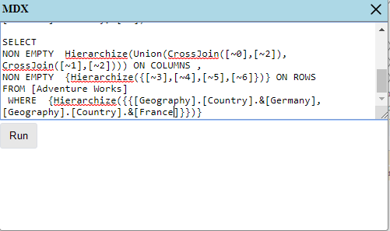
Figure 16: MDX Statement Showing the Revised WHERE Clause
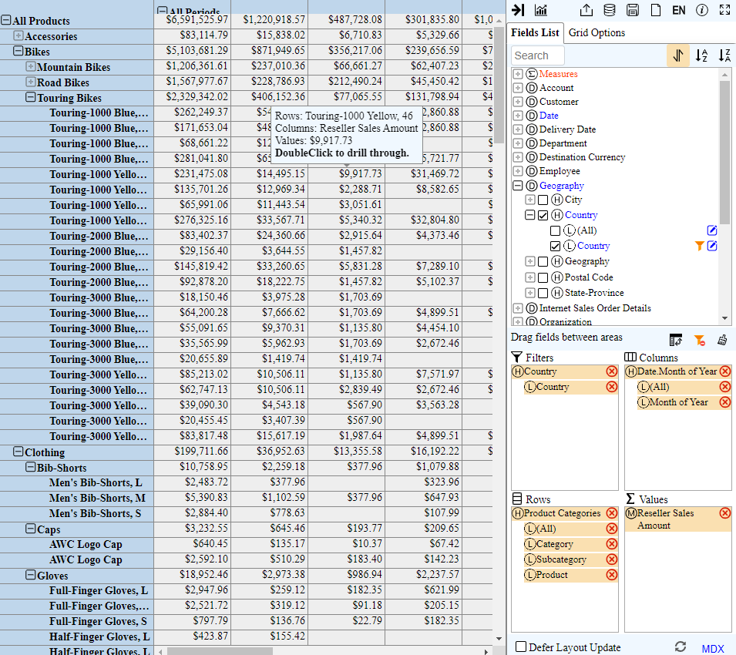
Figure 17: Pivot Table Showing Executed MDX Statement

Memory Mode
This tutorial only demonstrated OLAP Mode in which WebPivotTable acts as a client to an OLAP server. Since calculations are performed on the OLAP server, WebPivotTable has some limited features such as lacking support for aggregate calculations. You must setup the data cube on the OLAP server to perform aggregate calculations. Predetermined aggregate calculations appear in the Fields List for the Measures. For example, the Fields List of Measures for the AdventureWorks cube contains Average Sales Amount, Average Unit Price, and other aggregate calculations as well as basic measures.
To explore differences between Memory Mode and OLAP Mode, select a new data source and create a pivot table with the data source. Using Figure 18 as a guide, you should select Sales Sample Data as an Excel file. Figure 19 shows the empty pivot table.
In memory mode, WebPivotTable provides the calculation engine rather than relying on an external OLAP server. To demonstrate calculation capabilities in memory mode, configure a pivot table with City on the rows, Year-Id on the columns, and Sales(Sum) in the Values (Figure 20). To see available aggregate functions, you should select the edit button () for SALES(Sum) in the Values area. You can use a variety of aggregate functions using the Summarize Values By and Show Values As lists as shown in Figure 21.
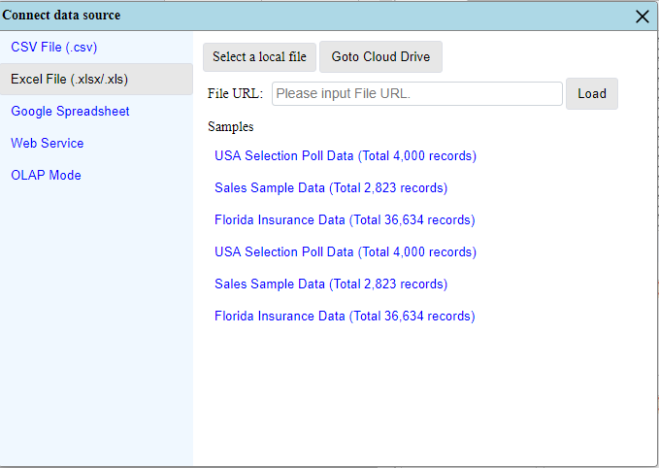
Figure 18: Connect Data Source Window with Excel File Choices
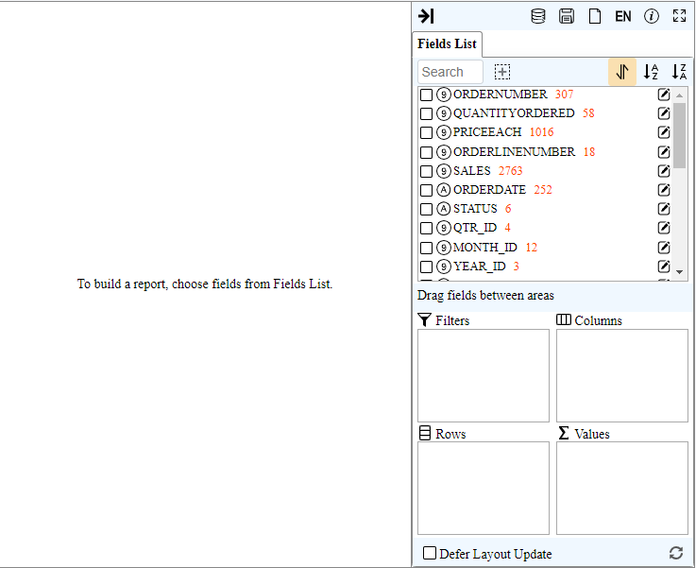
Figure 19: Empty Pivot Table with Sales Sample Data Source
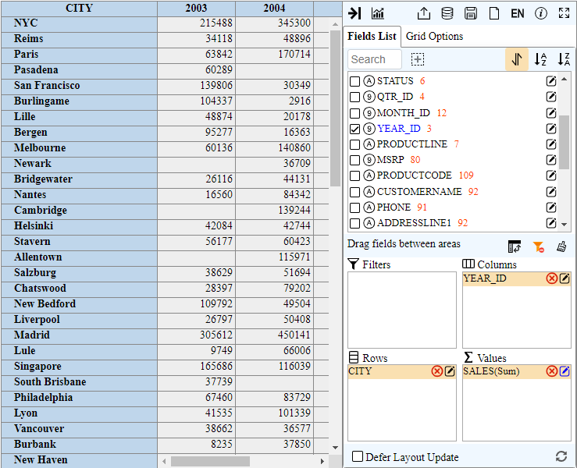
Figure 20: Pivot Table for Sales Sample Data
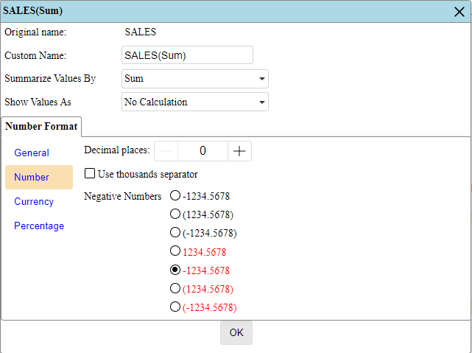
Figure 21: Edit Window for SALES(Sum) Field

The column labels on the top of the pivot table do not render correctly on three browsers (Chrome, Edge, and Firefox) in January 2020. The expanded column labels (Months of Year) do not display because of the incorrect rendering.

